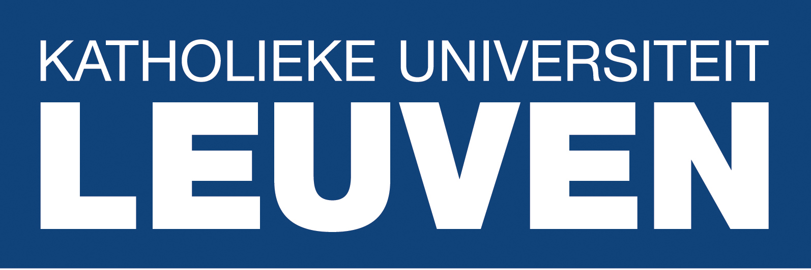

FOST – Social & Cultural
Food Studies

Call for Papers

FOST (Social & Cultural Food Studies), a leading research unit of Vrije Universiteit Brussel (VUB), Belgium, is pleased to announce the conference Food, Drink and 20th-Century Communism, to be held 19 and 20 April 2018 in Brussels, Belgium, in cooperation with the University of Leuven (KULeuven).

We are inviting proposals for paper presentations, addressing one of the following themes:

- Industrialization of food;
- Ideology and foodways;
- Cookery information and food recommendations;
- Forms of discontent through food;
- Specifics of money and time value under communism and their impact on people’s foodways;
- Food and gender;
- Public catering: ideological grounds and economic/cultural practices;
- National cuisines.

Papers on other themes, related to food production, foodways and food experiences in the period will also be considered. The call is open (but not limited to) researchers, working in the field of historical, cultural, anthropological, sociological studies. Comparative approaches are particularly welcome.

“There is nothing more critical to understand consumption under communism than food and drink”, wrote Bren & Neuburger in Communism Unwrapped (2012:165). Indeed the production and consumption of food, people’s foodways and their kitchens, being an intersection point of economics, politics and culture, offer encompassing and yet intimate insights into any given period of time. These perspectives, connecting social and private, can be also extraordinary eloquent. They make an excellent bridge between science and general public.

Food and drink in communism gained increasing interest in the last decades both in science and in post-communist societies. They were often considered from the point of view of consumption, as in the works of Gronow (2003) and Bren & Neuburger (2012), technological developments (Oldenziel & Zachman, 2009), or gender (Reid, 2002; Gvion, 2015). Crowley & Reid (2010) included them in their collection, focusing on the hedonistic side of life under communism. As part of the flow of studies on communist everyday life, this research started questioning the theoretical paradigms of the early post-communist years, adding nuance and detail, and sometimes radically rejecting the earlier approaches.

While the accumulation of work allowed for more solid references, there is little comparative work still done. This conference aims at both bringing the scattered research on food and drink in communism together, in its own right, and to encourage comparative studies, which would bridge the national research into a greater map of the Eastern part of the Iron curtain.

Cost of travel and stay
These should be covered by the participants. VUB provides a limited number of (affordable) accommodation upon request. Coffee and snacks will be provided during the conference days for the participants, and a welcome dinner will be offered.

Publication
A volume, containing the presented papers will be published within 12 months after the conference. The editors of the series European Food Issues (P.I.E. Lang, https://www.peterlang.com/view/serial/EUA) have shown huge interest in publishing this volume. A double blind peer review process will be applied so to assure optimal quality.

Abstract details:
Proposals should be submitted by September 15, 2017, and must include an abstract (250 words) of the paper to be presented and a brief biographical statement (100 words).
Final papers for publication should be submitted before 20 July 2018 They should be limited to 9.000 words, including bibliography, footnotes and endnotes, and the lay out and citations should be formatted according to P.I.E. Lang’s house style (to be provided in due time).

To express interest, answer queries, and send proposals, please write to Albena Shkodrova at albena.shkodrova@gmail.com.

