Application form – Session submission
Fourth International Convention on Food History and Food Studies
7-8 June 2018 – Tours (France)
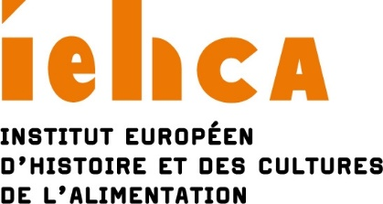

Please, note :

- Moderators are not allowed to give a paper in a session they moderate.

- The researcher submitting the proposal can be the moderator. However, if they are one of the speakers it is then their responsibility to find a moderator, failing which the organizers will designate one.

- Sessions will last 90 minutes in all. They should comprise a moderator and two papers of 30 minutes each in length or three papers of 20 minutes. Papers can be presented in English or French.

Session title

Participants

Organizer
Last name:
First name:
Institution** (if you are an independent researcher, please indicate your status):
Country:
Are you organizing several sessions? Yes No

Moderator
Last name:
First name:
Institution** (if you are an independent researcher, please indicate your status):
Country:

Speaker 1
Last name:
First name:
Institution** (if you are an independent researcher, please indicate your status):
Country:
Title of paper:

Speaker 2
Last name:
First name:
Institution** (if you are an independent researcher, please indicate your status):
Country:
Title of paper:

Speaker 3
Last name:
First name:
Institution** (if you are an independent researcher, please indicate your status):
Country:
Title of paper:

Email addresses/mobile phones

Organizer:

Moderator:

Speaker 1:

Speaker 2:

Speaker 3:

Abstract – 250 words – this abstract is likely to be published online

Speaker 1:

Speaker 2:

Speaker 3:

CV – 250 words

Organizer:

Moderator:

Speaker 1:

Speaker 2:

Speaker 3:

Important: do not indicate your research unite but only your main institution (university etc.).
Important: do not indicate your research unite but only your main institution (university etc.).

