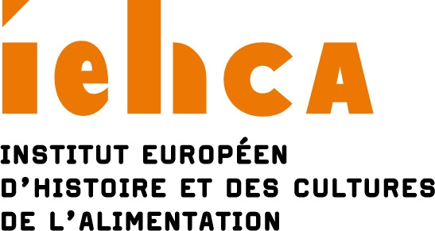

Dietary choices, instructions, and precepts – A multidisciplinary approach

Conference organized by the Institut Européen d’Histoire et des Cultures de l’Alimentation

Tours (France) - December 2-4, 2021

Call for papers

People’s diets, in addition to being governed by the capacity of ecosystems, are shaped by economic, social, cultural, religious, health, and medical norms, among others. Human food practices are thus necessarily framed by limits and opportunities, which may be internalized, deliberately taken up, or imposed. In which case, does it make sense to speak of choice?
What type of rules inform these usages? Are they instructions, precepts, or just advice? Are they imposed inherently, and, if not, who are the authorities laying them down? To what extent do time, place, and wider geographical context influence how they are elaborated? In the globalized world of the 21st-century, in which an abundance of food sometimes coexists with pathologies and chronic malnutrition posing a threat to people’s lives, how and in what hierarchy do individual’s food needs transpire within this broader framework?
Food choices and dietary instructions are depicted, particularly in literature and the arts, and these representations reveal how they are perceived, partaking in turn in their dissemination and elaboration.
This conference, which, it is hoped, will be attended by participants from all horizons and different disciplines in the social sciences, humanities, life sciences, and biomedicine, proposes to analyze this non-exclusive set of questions and considerations.

Many different themes could be examined, including for example: sumptuary laws; religious precepts and prohibitions; (past and present) purity and contamination; the present-day obligation to have a healthy diet; the notion of sobriety or, on the contrary, of sharing in libations; real or perceived constraints; diets; the rules governing family eating; limiting food waste; concern with animal welfare and that of the planet; systems to grade and label nutritional quality; malnutrition as an illness; and so on and so forth.

Long-term historical enquiry will focus on the origins of constraints on food practices, seeking to discern their initial reasons and trace their descent through various processes which, though forgotten, persist in implicit form. Archives and textual sources on which historical scholarship relies provide a rich set of data, but care will be required to disentangle the reality of practices from the web of norms underpinning them.
Polite usage and behavior deemed morally right—as codified in various types of guide or handbook on good manners—provide a clear example: to what extent were the ideals of moderation and self-control practiced by those exhorted to apply them? To what group did those obliged to follow strict rules belong? On this point, it is essential to take into account the connection between the private individual and the collective body. Individuals, either alone or in company, may well allow themselves freedoms with instructions to which their community—represented by the majority—are meant to conform: but is this freedom entire and complete?
Furthermore, food behavior acts as a marker of group-belonging, and it will be interesting to chart the path taken by such discriminatory practices over the long term, together with their legacies, alterations, re-creations, and inventions even. Are present-day vegans the same as the strict vegetarians who pioneered this practice? Historical analysis provides one line of enquiry for such questions based on a connection between past and present.
Dietary choices, instructions, and precepts may to an increasing extent be thought of in relation to the media, and arguably as being influenced by it. There is a constant circulation of discourse in the guise of expertise, advice, criticism, and personal testimony (now in blogs). Messages relayed by institutions (national schemes, communication campaigns by various organizations) and in the media (newspapers, advertising, and other documents) mean that everybody is aware, for example, of the recommendation to eat five fruit and vegetables a day, or of various formulae relating to a healthy balanced diet. It is a matter of striking a balance between health and pleasure, even if this entails being exposed to contradictory instructions. This is crystalized by the tension between the seductive messages put out by the food industry and the ceaseless bargaining between parents and children: “if you eat X, then you can Y”—a prime instance of dietary morality being tugged in different directions by media influences and the tensions between the social, political, cultural, and merchandising dimensions of food precepts, together with the social imaginary surrounding them.

For further information please contact Loïc Bienassis: loic.bienassis@iehca.eu
Papers may be presented in either French or English.
Proposals shall include:
- the title of the paper
- a 250-word abstract
- a brief cv
They are to be sent to Loïc Bienassis loic.bienassis@iehca.eu and Françoise Sabban francoise.sabban@ehess.fr before November 15, 2020.

Scientific committee for the conference:

Catherine Beaumont (INRA, Tours, France)
Loïc Bienassis (IEHCA, Tours, France)
Jean-Jacques Boutaud (Université de Bourgogne, Dijon, France)
Diana Cardenas Braz (Universidad El Bosque, Bogotá, Colombia).
Régis Hankard (Université de Tours, France)
Nathalie Peyrebonne (Université de la Sorbonne Nouvelle - Paris 3, France)
Françoise Sabban (École des Hautes Études en Sciences Sociales, Paris, France)
Carmen Soares (Universidade de Coimbra, Portugal)

